Perpustakaan Digital

Halaman Register

Halaman Login

Dashboard role (Visitor)

Detail buku

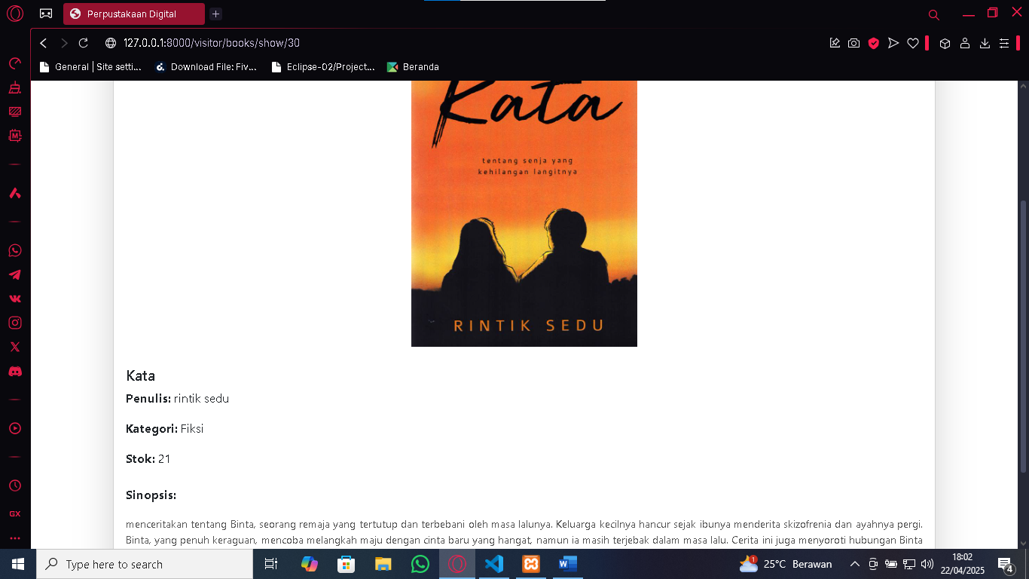

Peminjaman Buku

Daftar Peminjaman Buku

Dashboard role (admin)

Kelola Pengguna yg terdaftar

Daftar Buku (admin)

CRUD buku (admin)

Daftar peminjam Buku (Admin)

Laporan peminjaman buku menggunakan PDF (Admin)

Dashboard role (Officer)

